A new PubMed is on the way!

A new PubMed, with an updated interface and infrastructure, is coming soon. In the new PubMed, you’ll continue to have access to your favorite features, and you’ll have access to exciting new features.
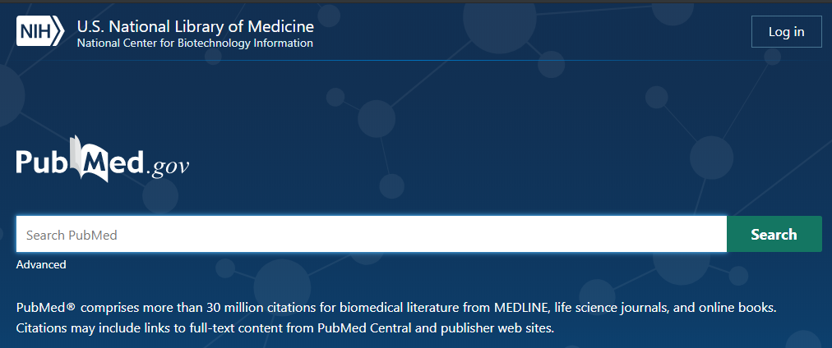
Learn more at the National Network of Libraries of Medicine (NNLM)
Resource Picks Webinar:

The New PubMed
November 20, 2019, 12-1PM Pacific
Register: https://nnlm.gov/class/new-pubmed/17937
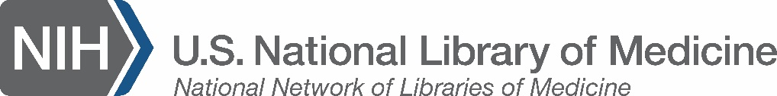
Questions?
Email Carolyn Martin
at martinc4@uw.edu

NNLM Resources Picks, PubMed  nnlm.gov/class/new-pubmed/17937 | NNLM Resources Picks, PubMed  nnlm.gov/class/new-pubmed/17937 | NNLM Resources Picks, PubMed  nnlm.gov/class/new-pubmed/17937 | NNLM Resources Picks, PubMed  nnlm.gov/class/new-pubmed/17937 | NNLM Resources Picks, PubMed  nnlm.gov/class/new-pubmed/17937 | NNLM Resources Picks, PubMed  nnlm.gov/class/new-pubmed/17937 | NNLM Resources Picks, PubMed  nnlm.gov/class/new-pubmed/17937 | NNLM Resources Picks, PubMed  nnlm.gov/class/new-pubmed/17937 | NNLM Resources Picks, PubMed  nnlm.gov/class/new-pubmed/17937 | NNLM Resources Picks, PubMed  nnlm.gov/class/new-pubmed/17937 | NNLM Resources Picks, PubMed  nnlm.gov/class/new-pubmed/17937

