Deliver Health Information to Your Community with Confidence
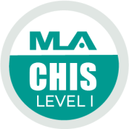
CHIS is an acronym for Consumer Health Information Specialization, a program provided by the Medical Library Association. The CHIS offers training in providing health information services to consumers and recognition for the accomplishment of acquiring new health information skills.
Librarians know the life-saving and life-enhancing value of accurate evidence-based health information. By earning CHIS, you acquire skills and knowledge needed to become a confident, expert provider of health information to your community. Your CHIS shows employers, colleagues, and the public you serve that you are committed to offering quality consumer health information services and to staying current with developments in consumer health information resources, technologies, and services.
NNLM Sponsorship: NNLM sponsors the CHIS application fee for level 1 or level 2 for library workers, allowing you to get the specialization for free. Refer to the NNLM Specialization Guide at the link below for more information on CHIS.
For upcoming CHIS courses: NNLM Specialization Guide:
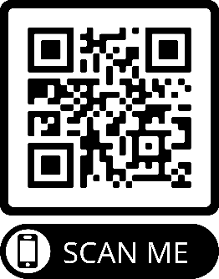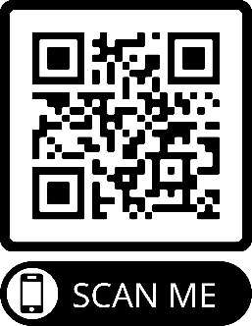
https://bit.ly/CHIS_class_schedule https://nnlm.gov/guides/specialization

